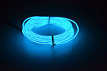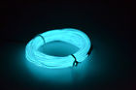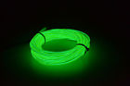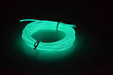

# **1/2/3/4/5M Flexible Led EL Tube Wire Neon Glow Decor Light +3V/12V controller**

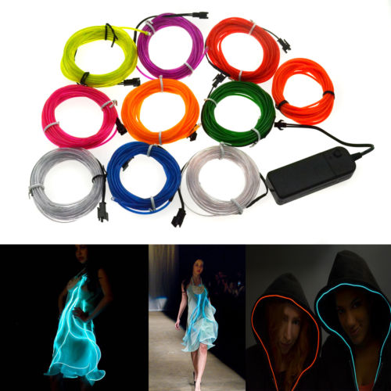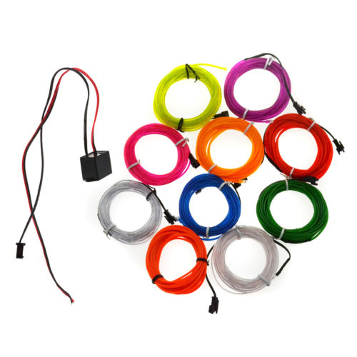

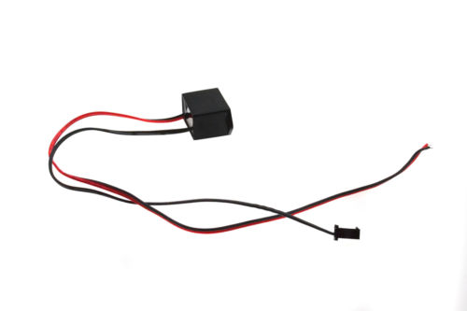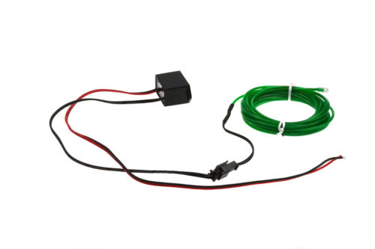

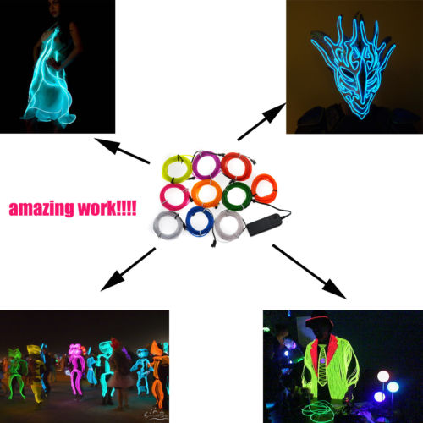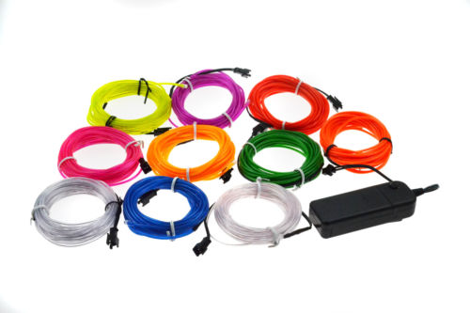

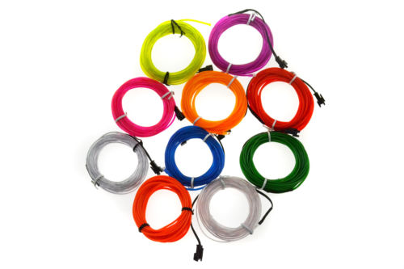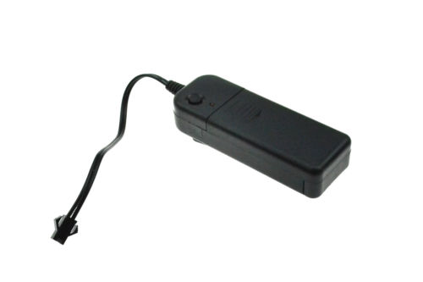

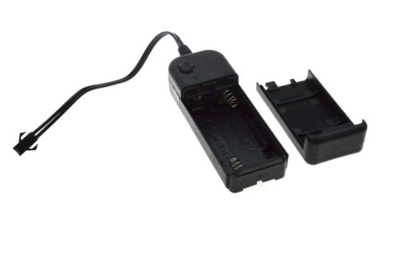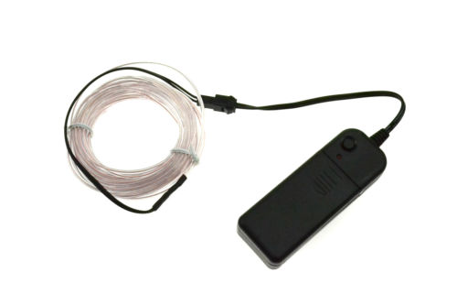

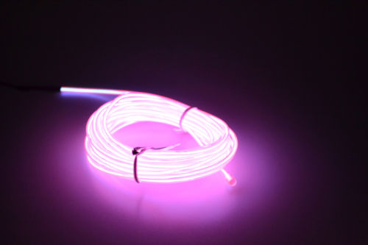

## **Description**

[**Click here to buy long el wire and other controller**](http://www.ebay.com/itm/Colorful-El-Wire-Led-Tube-Strip-Neon-Rope-Glow-Light-Car-Party-Decor-Controller-/291620688734?tfrom=291353909733&tpos=unknow&ttype=price&talgo=origal)

**Features**

Flexible and water resistant, can be bent into any shapes and cut into any length.

Offer 360 degrees of illumination.

Energy saving and environmental-friendly.

Long life time, more than 12,000 hours.

For 3V Controller: 3 light modes: steady on, quick flash, slow flash.

Great for car decoration, night clubs, parties, dark hallways, almost wherever you can imagine.

You can also use it around the spokes of your bike tires, your wrists, even your pet's collar for extra protection in the evening.

**Specifications**

Color: 10colors

Wire diameter: 2.3mm

Wire length: 1M/2M/3M/5M

Life time: >12,000 hours

Working temperature: - 30℃ ~ 80℃

3V controller Powered by 2 * AA batteries (not included)

Lookup